

Environmental Issues of Canada

Data Analysis with High altitude and longtitude

## Bushra | Capstone Project - The Battle of Neighborhoods | 1/9/2019

# **Problem**:

Places located at high latitudes (far from the equator) receive less sunlight than places at low latitudes (close to the equator). The amount of sunlight and the amount of precipitation affects the types of plants and animals that can live in a place.

Canada is largely defined by its size, as the second-largest country in the world, and sparse population, with about 75 percent of Canadians living within 100 miles of the United States of America. The Canadian population is also highly concentrated around its cities, outside of southern Ontario.

**Target audience:**

Potential clients look to buy suitable property in Canada, Government and global environmental concerns groups and institutions.

**Stakeholders:**

1. Canada municipality / Canadian Government / Neighborhood Countries
2. Sellers
3. Buyers
4. Real estate agents

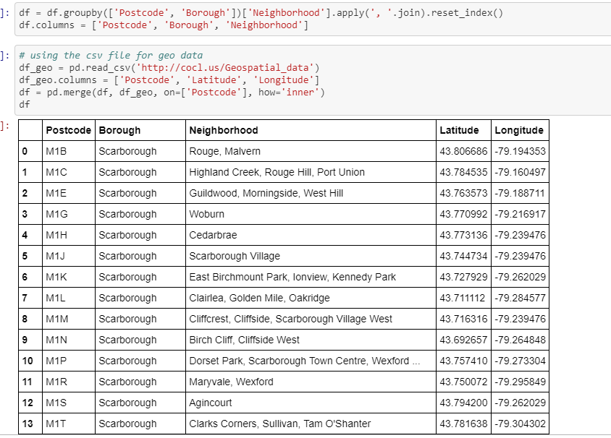

Solution:

* Energy conserved/wasted
* Waste produced/recycled
* Environmental damage Precautions
* Potential investment for recycling of materials